Refugee kids in Australia: No bombs, English classes and trying Vegemite
By education reporter Natasha Robinson
Their lives were uprooted by a brutal and relentless war. Villages were bombed and walking to school sometimes meant dodging gunfire that ricocheted around the streets.

Key points:
- Of the 12,000 Syrian refugees resettled in Australia, 4,350 are children
- The NSW Government will provide an extra $2.7 million for independent and Catholic schools to offer specialist programs
- But Holy Saviour Catholic School in Sydney's southwest says the extra funds only cover about a third of what it spends
The Syrian children who Australia welcomed as refugees during the past year — 4,350 of them — face enormous challenges settling into their new life.
Not only are they learning to speak a new language, they must learn maths, science and read school texts in English too.
The trauma of war-torn Syria, and the dislocation from extended family, is still fresh.
One of the anxieties of politicians and policymakers in recent times has been the level of success of the integration of migrants from countries with large cultural differences, such as the Middle East and sub-Saharan Africa.
Today, schools are playing a central role in cultural integration.
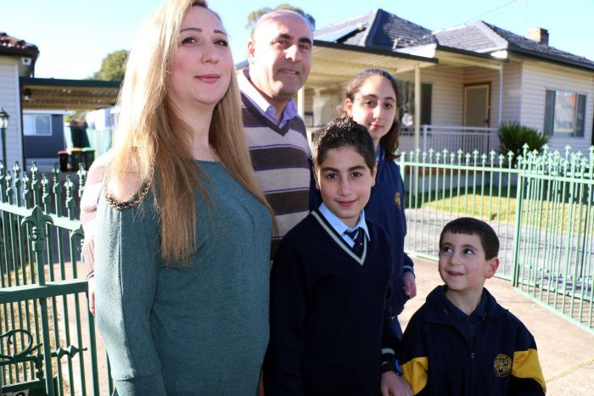PHOTO: The Manjeh family are among 12,000 Syrian refugees resettled in Australia. (ABC News: Natasha Robinson)
On a quiet suburban street in the western Sydney suburb of Yagoona, Yorka Manjeh and her husband Samir are getting their three children — Sara, Dani and Semon — ready for school.
Sweet black tea is on the table amid the breakfast bowls, school folders and lunchboxes.
"The kids feel so safe in Australia," Mrs Majeh said. "They travel happily to and from school every day.
"They wake up in the morning looking forward to going to school because they are learning lots of new things — much more than in Syria."
Like 90 per cent of Syrian refugees accepted in the past 12 months, the family are Christians.
The children attend Holy Saviour Catholic School in nearby Greenacre. Sara is in year 6.
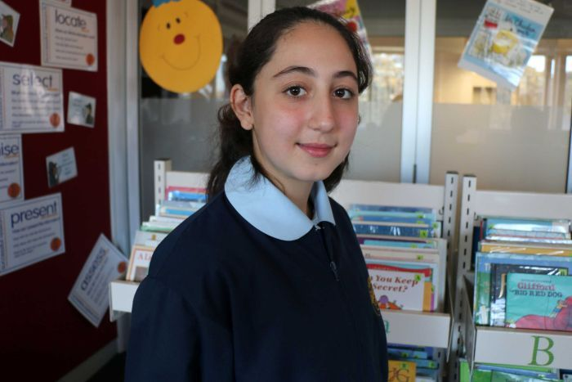PHOTO: Sara Manjeh says she likes the freedom of being able to play with her friends at school. (ABC News: Natasha Robinson)
"I missed a year of school in Syria because there was the war and people shooting," she said. "If we go to school, we might get shot.
"When we came to Australia I felt free because I can go to school and play with my friends. I'm not staying at home all the time."
Accommodating a sudden influx of refugee children hasn't been easy for schools.
A large percentage of the 12,000 refugees that Australia accepted have settled in the Fairfield local council area in south-west Sydney, where schools already cope with limited resources to educate the large proportion of children who speak English as a second language.
For Holy Saviour School, supporting refugee students meant hitting the streets to rustle up community donations.
The NSW Government has announced it will provide $2.7 million for independent and Catholic schools to offer specialist programs for refugees.
That's in addition to a wider package of $93 million over four years for refugee students.
But the extra funds only account for about a third of what Holy Saviour spends.
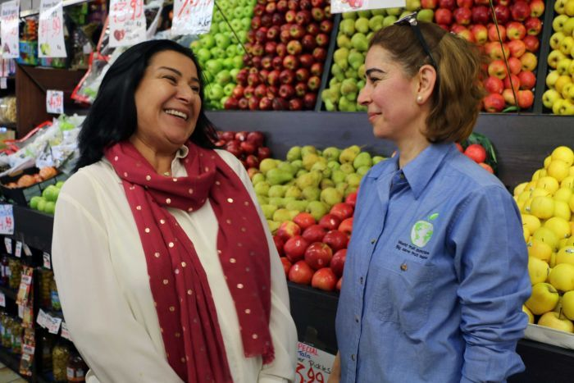PHOTO: Principal Dianne Klumpp (left) says the school looked to the Greenacre community to assist and support them. (ABC News: Natasha Robinson)
"At first, we had no financial assistance or support," said Holy Saviour principal Dianne Klumpp, who personally knocked on the doors of local businesses to ask for help.
"We looked to the community to assist and support us anonymously.
"We managed to raise $40,000 through community partnerships, tighten our budgets a bit and put $90,000 towards the 2017 program we've put in place.
"We've been able to offer children three hours of support in intensive English a day.
"But we need approximately another $180,000 to $200,000 if we're to continue the current program that we have in place for the existing children."
And how is she going to raise that money?
"Beg, borrow, and steal," Ms Klumpp said. "We believe that we can do justice by these children."
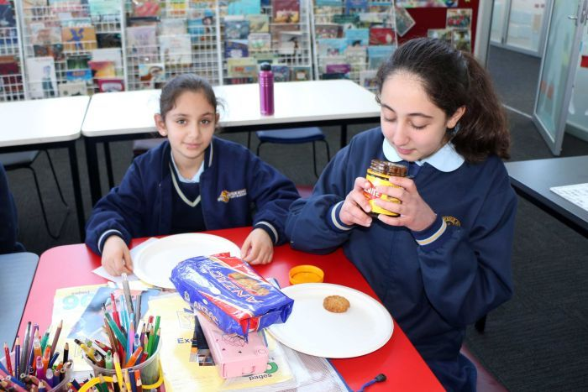PHOTO: Sara's Vegemite verdict: "It's disgusting." (ABC News: Natasha Robinson)
In the Syrian children's intensive language classes, a New Arrivals program gives kids a hands-on experience of Australian culture in their classrooms.
When the ABC visited Holy Saviour school, children were sitting at a table surrounded by jars of Vegemite and Anzac biscuits.
Sara has just tried Vegemite for the first time. "It's disgusting," she said.
New Arrivals teacher Rosina Schinella said the program integrated cultural concepts with Australian books and literacy instruction.
"They're open to learning new things, they want to learn, they want to embrace, they want to be part of the culture."
Syrian children who came to Australia prior to the current refugee influx have proven they can master English, integrate into a new country and become school leaders in just a few short years.
Holy Saviour's school captain, Youssef Albaba, is one of those children. He's been in Australia for three-and-a-half years and wears his captain's badge every day with pride.
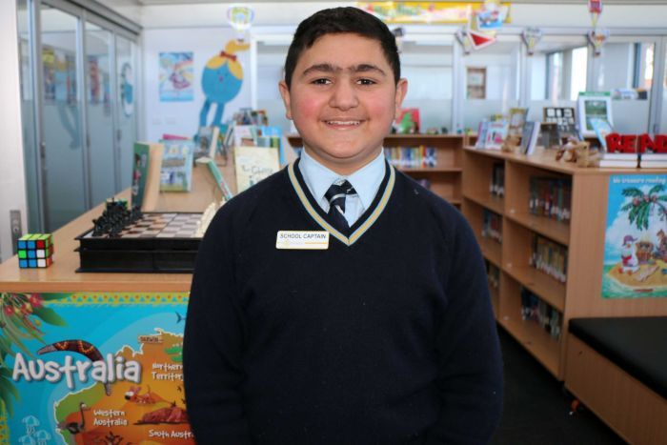PHOTO: Holy Saviour school captain Youssef Albaba hopes to one day be "a priest or a doctor or an engineer".(ABC News: Natasha Robinson)
"In Syria they used to hit us at the school, here they don't hit us," Youssef said.
"Our home in Syria, our village, some houses got broken, fall down from the bombs and the bullets.
"Here, the school is bigger. In Australia, for 24 hours we've got electricity. In Syria we used to have only two hours.
"Now, we've got the principal, we've got the teachers. They're all the best. And here it's learning — it's easier [than] Syria."
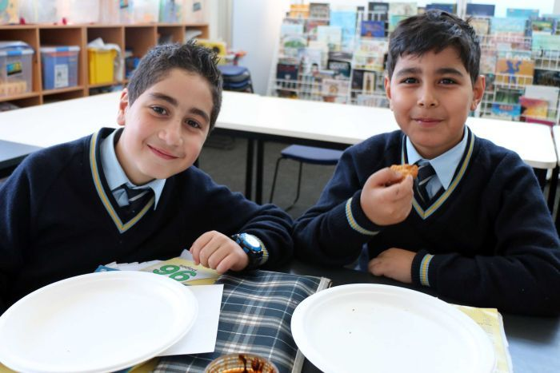PHOTO: Holy Saviour Catholic School gives kids a hands-on experience of Australian culture. (ABC News: Natasha Robinson)
As he progressed into his senior primary years, Youssef set his sights on becoming school captain.
"I start to be nice to people," he said. "I start to work with the principal and be close to the teachers, and to the kids I do whatever they wanted so they voted for me and I became school captain."
Asked what he would like to be, Youssef answered: "Probably a priest or a doctor or an engineer."
And he has one hope for his home country.
"I hope Syria will become better and there wouldn't be any more wars. In the whole world, we don't want any wars."

